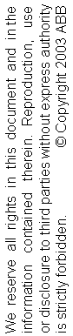
Transplant Slave IP for Current Controller Description

Edition | Date | Issued by | Comments
0.1 | 2009-09-23 | CNABB/Ye-Ye Zhang | Proposal
0.2 | 2009-09-29 | CNABB/Ye-Ye Zhang | Revised in detail

TABLE OF CONTENTS

1. INTRODUCTION 3
2. OVERVIEW 4
3. detailed description 6
3.1 Main State Machine 6
3.2 Slave Controller State Machine 7
3.3 Legacy ESM State Machine 8
3.4 SDO Adapter 10
3.5 Cyclical State Machine 11
3.6 FSL Adapter 12
3.7 Memory Map 13
4. TestBench 16
5. protocols and editions 18

INTRODUCTION
This document contains the transplant description of the Current Controller Slave IP core from Firmware C19.

The IP core shall be used in the Current Controller FPGA and it shall be connected with an embedded CPU through a FSL bus. There shall be a CC IP driver in this CPU. It gets PWM process data and ADC command from CPU or BRAM and sends to CC IP via FSL bus; and then it receives ADC feedback data from CC IP and puts to CPU or BRAM.

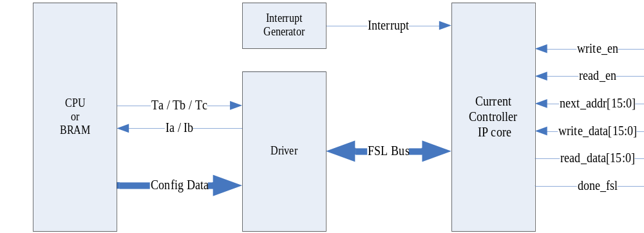

This document only describes the essential transplantation of the Firmware C19. The firmware should inherit most of the C19 functions. The functions described in this document should be limited to changing parts during the transplantation. It is strongly recommended to understand the mechanism of Firmware C19 before reading this document.

OVERVIEW
This document describes the transplantation from FW C19 to IP core for slave MicroBlaze in Current Controller for Gear Assembly production. This IP core remains most of the function in FW C19. And the cut line for transplant is decided to be set between the EtherCAT and the 16-bit uController.

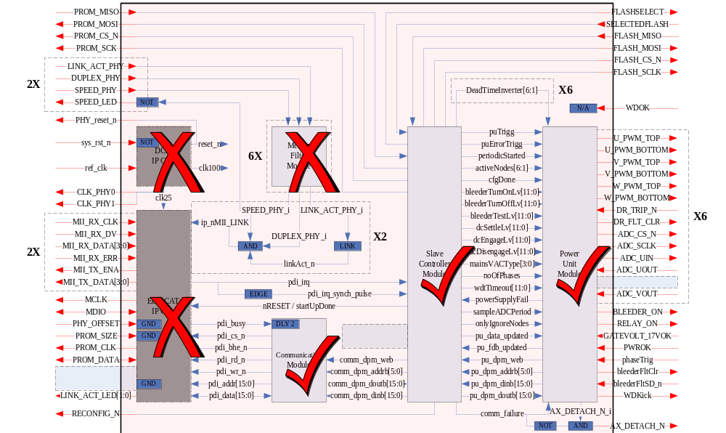
Fig 1 Implemented Parts of the FPGA C19

The FW C19 transplantation is designed for the whole logic parts of FW C19, which is implemented in Fig 1. It is based on the FW C19 IP Core without EtherCAT (etc). Here, 16-bit uController is replaced by FSL Adapter; mailbox mechanism is replaced by SDO Adapter, as shown in Fig 2.

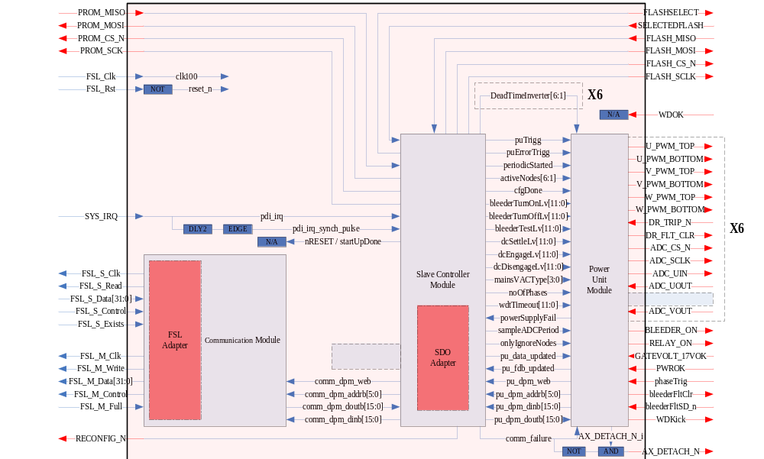
Fig 2 Architecture of the FPGA C19 Transplantation

Note that FSL_Rst signal is inverted to reset_n in this IP core.

Interrupt signal Irq is generated by other IP core and controlled by CPU. The Irq needs to be delayed for 2 ticks and then be edge trigged as only one tick signal pulse for SC event trigger. The delay and edge-trig of this Irq is done inside this Current Controller Slave IP core.

detailed description

Main State Machine
The main state machine in this firmware follows the original ESM (EtherCAT State Machine). It fulfils the protocol with Current Controller Microblaze as follow.

Init
1
.
Write FSL with 4 words to tell CPU
that CC IP core is ready to work
Pre
-
op
Boot
Safe
-
op
Op
wait pre-op
command
from CPU
reset
wait boot
command
from CPU
reset
wait safe-op
command
form CPU
reset
reset
errors appear from
CC IP core or
hardware itself
3
.
Write FSL with 2 words to put
State Change status to CPU
4
.
Read FSL with 2 words to get
Configuration command from CPU
5
.
Read FSL with 18 words to get
Configuration data from CPU
2
.
Read FSL with 2 words to get
State Change command from CPU
7
.
Write FSL with 2 words to put
State Change status to CPU
6
.
Read FSL with 2 words to get
State Change command from CPU
wait pre-op
command
form CPU
wait op
command
form CPU
12
.
Write FSL with 2 words to put
State Change status to CPU
11
.
Read FSL with 2 words to get
State Change command from CPU
8
.
Read FSL with 1 word to get
Process command from CPU
9
.
Read FSL with 20 words to get
Process data from CPU
10
.
Write FSL with 20 words to put
Feedback data to CPU
13
.
Read FSL with 1 word to get
Process command from CPU
14
.
Read FSL with 20 words to get
Process data from CPU
15
.
Write FSL with 20 words to put
Feedback data to CPU
Fig 3 Main State Machine

State | Description
Init | Startup
Bootstrap | Reset
PreOP | Configuration
SafeOP | Process data input to CPU
OP | Process data input and output

State Transition | Description
To_Init | Set to startup (available from each state to Init state)
Bootstrap_Init | Restart from boot
Init_Bootstrap | Set to be ready for restart
Init_PreOP | Start configuration
PreOP_SafeOP | Start process data input
SafeOP_OP | Start process data output
OP_SafeOP | Stop process data output
SafeOP_PreOP | Stop process data input
OP_PreOP | Stop process data input and output

Slave Controller State Machine
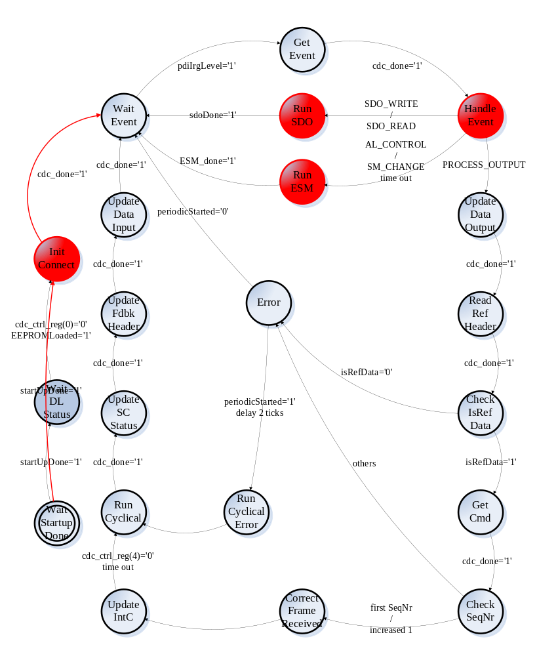
Fig 4 Slave Controller State Machine

InitConnect | Addr | Value
FW_Revision | 0x1004 | 0x0035
PU_DSQC | 0x1006 | 0x0299
PU_Version | 0x1008 | 0x0001
PU_Revision | 0x100A | 0x0001

AL Event Request Mask | Addr
AL_Event_Request_addr | 0x0220

AL Event Request Mask | Value
AL_CONTROL_EVENT | 0x0001
SM_CHANGE_EVENT | 0x0010
SDO_WRITE_EVENT | 0x0100
SDO_READ_EVENT | 0x0200
PROCESS_OUTPUT_EVENT | 0x0400

FILE_LOCATION_ADDR | Addr
ECS_Process_Data_Output_Start_Addr | 0x1100
ECS_Process_Data_Input_Start_Addr | 0x1300

Ref Header | Value
(7 DOWNTO 0) driveUnitType | in drive unit header for use with wireshark
(11 DOWNTO 8) RefSeq | increased by 1 since last frame
(15) isReferenceData | 1

Unit Cmd | Value
(0) resetCommFailure | 0; 1 for reset
(2) sampleADCEveryPeriod | 0 / 1

Legacy ESM State Machine

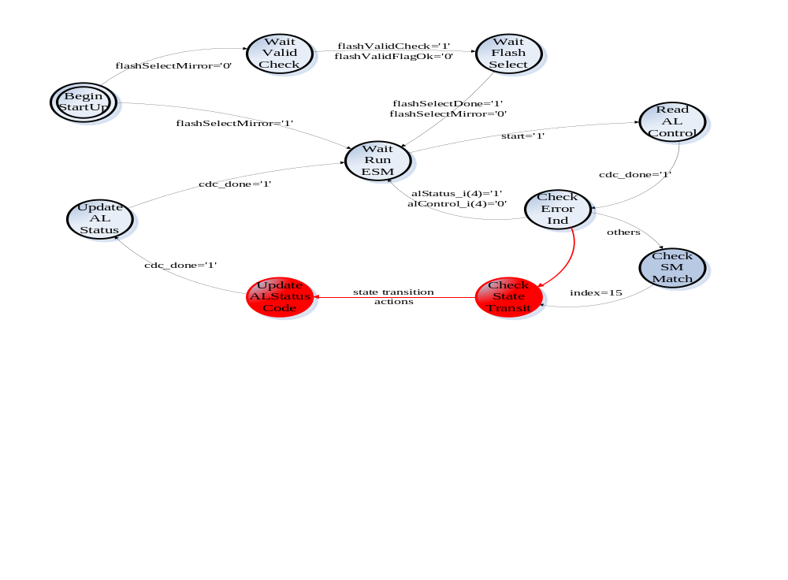
Fig 5 State Machine of Legacy ESM

AL Event Request Mask | Addr
AL_CONTROL_ADDR | 0x0120
AL_STATUS_CODE_ADDR | 0x0134
AL_STATUS_ADDR | 0x0130

AL Control / Status State | Value
alControl(4) / alStatus(4) | 0
INIT_STATE | 0x1
BOOTSTRAP_STATE | 0x3
PRE_OP_STATE | 0x2
SAFE_OP_STATE | 0x4
OP_STATE | 0x8

Note that, the alControl(4) is the Error Ind Ack bit: 0 for No Ack of Error Ind in AL status register; 1 for Ack of Error Ind in AL status register. Meanwhile, the alStatus(4) is the Error Ind bit: 0 for Device is in State as requested or Flag cleared by command; 1 for Device has not entered requested State or changed State as result of a local action. Bit 15 downto 5 of both alControl and alStatus are kept reserved as 0.

AL Status Code | Value
No error | 0x0000
Unspecified error | 0x0001
Invalid requested state change | 0x0011
Unknown requested state | 0x0012
Bootstrap not supported | 0x0013
No valid firmware | 0x0014
Invalid mailbox configuration | 0x0015
Invalid mailbox configuration | 0x0016
Invalid syncmanager configuration | 0x0017

SDO Adapter
The mailbox will be replaced as follow. This block’s function is to copy data between the FSL Bus and the SDO process. This state machine architecture is referenced to the cyclical block.
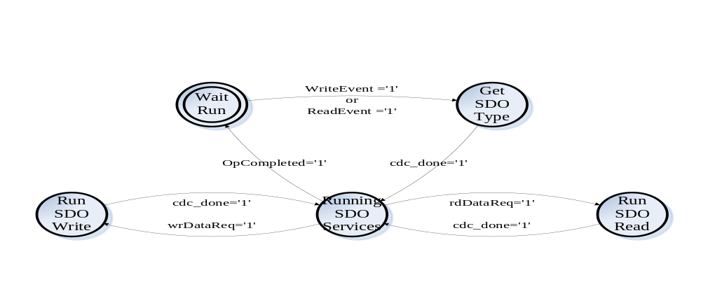
Fig 6 State Machine of SDO Interface

FILE_LOCATION_ADDR | Addr
FILE_LOCATION_ADDR | 0x0770

FILE_LOCATION | Value
RESERVED_LOCATION | 0x0
FPGA_FW_INFO_MEM | 0x1
EEPROM_MEM | 0x2
FLASH_MEM | 0x4
FPGA_APPLIC_CONF_DATA_MEM | 0x5

The configuration data during config sequence of the startup is listed below.

Size in bits | Word addr | Field | Description
4 | 0x00 | MaxLostFrames | Maximum Number of Lost/ignored  consecutive reference messages.
8 | 0x01 | MDUProtocolVersion | Process data protocol version for MDU:s
12 | 0x02 | ADC_BleederTurnOnLevel | Rectifier Config. A/D converter value for turn on level for the bleeder.
12 | 0x03 | ADC_BleederTurnOffLevel | Rectifier Config. A/D converter value for turn off level for the bleeder.
12 | 0x04 | ADC_BleederTestLevel | Rectifier Config. A/D converter value representing the DC level that the DC link shall drop to when engaging the bleeder during startup test
12 | 0x05 | ADC_DCSettleLevel | Rectifier Config. A/D converter value representing that DC is stable when its ripple is less than this value
12 | 0x06 | ADC_DCEngageLevel | Rectifier Config. A/D converter value for engage the relays, i.e. switching inrush circuit to running mode
12 | 0x07 | ADC_DCDisengageLevel | Rectifier Config. A/D converter value for disengage the relays, i.e. switching inrush circuit to charging mode
4 | 0x08 | RectifierConfigValid | Mains AC Type:  0 – Not Configured  1 – Configured  2 – 15 Reserved
1 | 0x09 | OnePhaseMains | 0 – Three Phases  1 – One Phase
12 | 0x0A | DeadtimeInverter1 | Deadtime in 10 ns resolution
12 | 0x0B | DeadtimeInverter2 | Deadtime in 10 ns resolution
12 | 0x0C | DeadtimeInverter3 | Deadtime in 10 ns resolution
12 | 0x0D | DeadtimeInverter4 | Deadtime in 10 ns resolution
12 | 0x0E | DeadtimeInverter5 | Deadtime in 10 ns resolution
12 | 0x0F | DeadtimeInverter6 | Deadtime in 10 ns resolution
16 | 0x10 | WatchdogTimeout | 10 ns resolution-value to use as timeout when no data is received by the Slave. The supervision should be enabled when the first package arrive after entering OP state.
16 | 0x11 | WatchdogTimeoutInterval | 10 ns resolution-value to use as timeout for next package when a package is lost.

Hardcode values in MDU firmware

Size in bits | Field | Description
8 | FW version
8 | FW revision
8 | Latest MDU RoboCAT version supported
14 | PWM delay time min value | Number of 10 ns ticks
14 | PWM delay time max value | Number of 10 ns ticks

Cyclical State Machine
Process data area for outputs

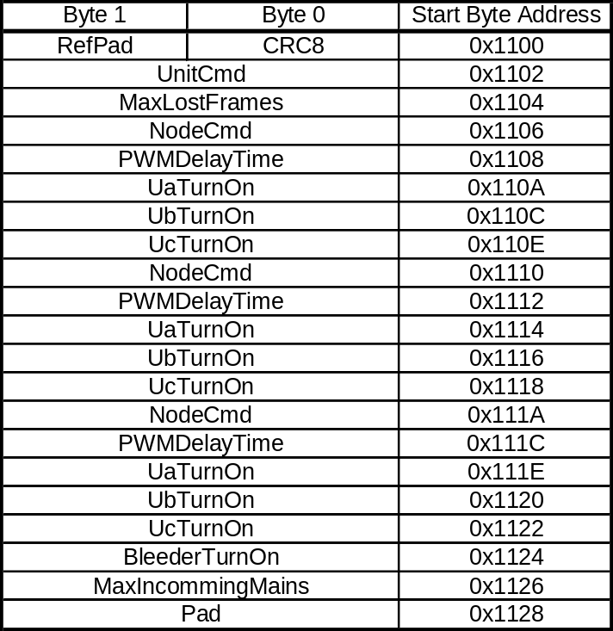

Process data area for inputs

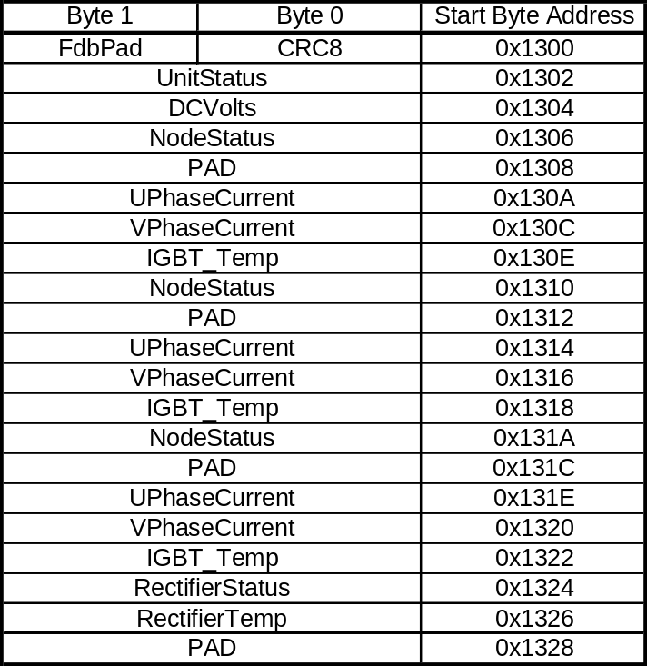

FSL Adapter

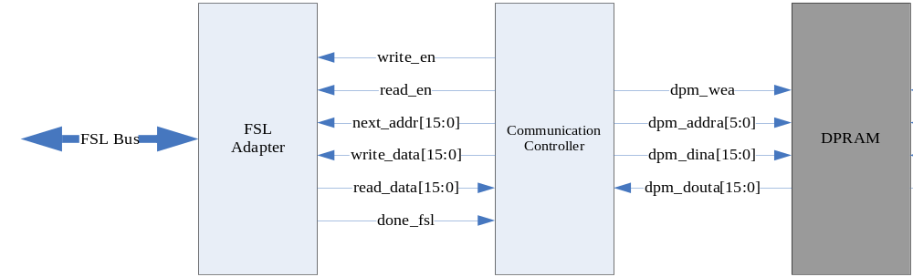Fig 7 Structure of Communication Module

FSL Bus width is 32 bit. The high 16 bit indicates the legacy address (_addr[15:0]); and the low 16 bit indicates the data. When receive the FSL 32 bit data, FSL Adapter automatically check the legacy address, which should accords to input address (_addr[15:0]). Otherwise, the data will be dropped with warning. No Register Array or DPM exists in FSL Adapter. The transfer data will be blocked in the buffer of FSL Bus. After one operation cycle is done, the FSL Adapter sends a done_fsl signal pulse.

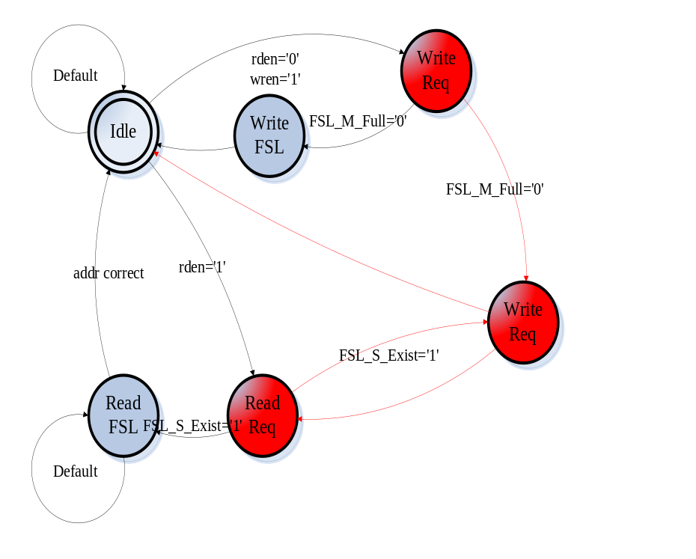
Fig 8 State Machine of FSL Adapter

Memory Map

Table 1 shows the memory map in EtherCAT State Machine, it includes the control/status registers and input/output data.

Table 1 Memory Map in Current Control IP Core
Type | Name | ESM  (8bit) | Comm DPM | SC DPM | Value
 | Physical Start Address | 0x0000 |  |  | unfixed
 | Length | 0x0002 |  |  | unfixed
 | Control Register | 0x0004 |  |  | unfixed
 | Status Register | 0x0005 |  |  | unfixed
 | Activate | 0x0006 |  |  | unfixed
 | PDI Control | 0x0007 |  |  | unfixed
 | DL_Status | 0x0110 |  |  | 1 for ok
 | AL_Control | 0x0120 |  |  | defined
 | AL_Status | 0x0130 |  |  | defined
 | AL_Status_Code | 0x0134 |  |  | 0x0000
 | PDI Control | 0x0140 |  |  | 1 for ok
 | AL_Event_Mask 1 | 0x0204 |  |  | unfixed
 | AL_Event_Mask 2 | 0x0206 |  |  | 0x0000
 | AL_Event_Request | 0x0220 |  |  | defined
 | Watchdog Divider | 0x0400 |  |  | unfixed
 | Watchdog Time PDI | 0x0410 |  |  | unfixed
 | Watchdog Time Process Data | 0x0420 |  |  | unfixed
 | Watchdog Status Process Data | 0x0440 |  |  | unfixed
 | Watchdog Counter Process Data | 0x0442 |  |  | unfixed
 | Watchdog Counter PDI | 0x0443 |  |  | unfixed
 | SyncManager[0] | 0x0806 |  |  | 0x0100
 | SyncManager[1] | 0x080E |  |  | 0x0100
 | SyncManager[2] | 0x0816 |  |  | 0x0100
 | SyncManager[3] | 0x081E |  |  | 0x0100
 | SyncManager register | 0x0826 |  |  | 0x0100
 | SyncManager register | 0x082E |  |  | 0x0100
 | SyncManager register | 0x0836 |  |  | 0x0100
 | SyncManager register | 0x083E |  |  | 0x0100
 | SyncManager register | 0x0846 |  |  | 0x0100
 | SyncManager register | 0x084E |  |  | 0x0100
 | SyncManager register | 0x0856 |  |  | 0x0100
 | SyncManager register | 0x085E |  |  | 0x0100
 | SyncManager register | 0x0866 |  |  | 0x0100
 | SyncManager register | 0x086E |  |  | 0x0100
 | SyncManager register | 0x0876 |  |  | 0x0100
 | SyncManager register | 0x087E |  |  | 0x0100
 | User RAM | 0x0F80 |  |  | 0x0000
 | FW_REVISION | 0x1004 |  |  | 0x0035
 | PU_DSQC | 0x1006 |  |  | 0x0299
 | PU_Version | 0x1008 |  |  | 0x0001
 | PU_Revision | 0x100A |  |  | 0x0001
 | CTRL_REG |  | 0x0000
 | Status_reg |  | 0x0001
 | Config_reg |  | 0x0002
 | DATA_REG |  | 0x0003
 | ADDR_REG |  | 0x0004
 | RefPad & CRC8 (RefHeader) | 0x1100 | 0x0005
 | UnitCmd | 0x1102 | 0x0006 | 0x0000
 | MaxLostFrames | 0x1104 | 0x0007
 | NodeCmd | 0x1106 | 0x0008 | 0x0001
 | PWMDelayTime | 0x1108 | 0x0009
 | UaTurnOn | 0x110A | 0x000A | 0x0002
 | UbTurnOn | 0x110C | 0x000B | 0x0003
 | UcTurnOn | 0x110E | 0x000C | 0x0004
 | NodeCmd | 0x1110 | 0x000D | 0x0005
 | PWMDelayTime | 0x1112 | 0x000E
 | UaTurnOn | 0x1114 | 0x000F | 0x0006
 | UbTurnOn | 0x1116 | 0x0010 | 0x0007
 | UcTurnOn | 0x1118 | 0x0011 | 0x0008
 | NodeCmd | 0x111A | 0x0012 | 0x0009
 | PWMDelayTime | 0x111C | 0x0013
 | UaTurnOn | 0x111E | 0x0014 | 0x000A
 | UbTurnOn | 0x1120 | 0x0015 | 0x000B
 | UcTurnOn | 0x1122 | 0x0016 | 0x000C
 | BleederTurnOn | 0x1124 | 0x0017 | 0x000D
 | MaxIncommingMains | 0x1126 | 0x0018 | 0x000E
 | Pad | 0x1128 | 0x0019
input data | FdbPad & CRC8 (FdbkHeader) | 0x1300 | 0x001B | 0x0018
input data | UnitStatus | 0x1302 | 0x001C | 0x0019
input data | DCVolts | 0x1304 | 0x001D | 0x0020
input data | NodeStatus | 0x1306 | 0x001E | 0x0021
input data | PAD | 0x1308 | 0x001F
input data | UPhaseCurrent | 0x130A | 0x0020 | 0x0022
input data | VPhaseCurrent | 0x130C | 0x0021 | 0x0023
input data | IGBT Temp | 0x130E | 0x0022 | 0x0024
input data | NodeStatus | 0x1310 | 0x0023 | 0x0025
input data | PAD | 0x1312 | 0x0024
input data | UPhaseCurrent | 0x1314 | 0x0025 | 0x0026
input data | VPhaseCurrent | 0x1316 | 0x0026 | 0x0027
input data | IGBT Temp | 0x1318 | 0x0027 | 0x0028
input data | NodeStatus | 0x131A | 0x0028 | 0x0029
input data | PAD | 0x131C | 0x0029
input data | UPhaseCurrent | 0x131E | 0x002A | 0x002A
input data | VPhaseCurrent | 0x1320 | 0x002B | 0x002B
input data | IGBT Temp | 0x1322 | 0x002C | 0x002C
input data | RectifierStatus | 0x1324 | 0x002D | 0x002D
input data | RectifierTemp | 0x1326 | 0x002E | 0x002E
input data | PAD | 0x1328 | 0x002F
input data | HEATsink_TEMP |  |  | 0x0020
input data | RectifierCurrent |  |  | 0x002F
input data | ACVolts |  |  | 0x002F
input data | RECT_REF_PAD1 |  |  | 0x0011
input data | RECT_REF_PAD2 |  |  | 0x0012
input data | PWM_CTRL |  |  | 0x003F
input data | PWM_CFG |  |  | 0x003d
input data | MB_WRITE_BUFF_START | 0x1600
input data | MB_READ_BUFF_START | 0x1750

TestBench
The diagrams of testbench, FSL Adapter and SDO Adapter are listed below.
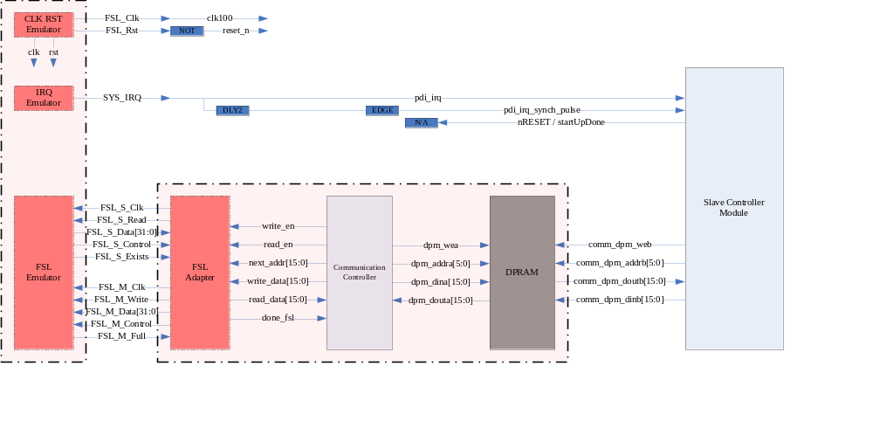
Fig 9 Diagram of FSL Adapter in Firmware Architecture

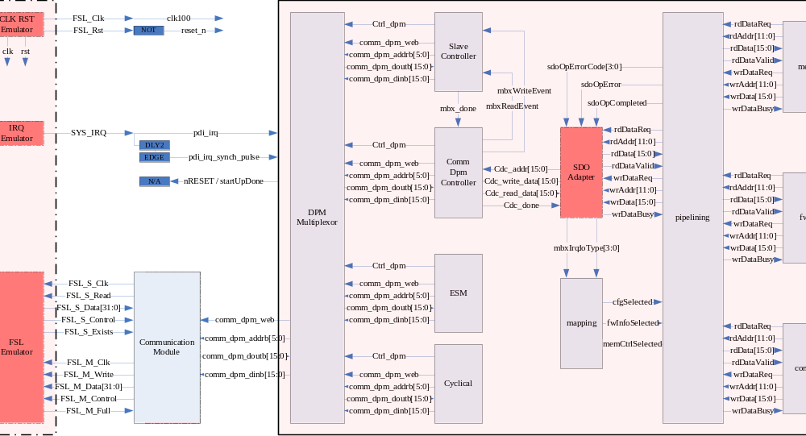 Fig 10 Diagram of SDO Adapter in Firmware Architecture

The FSL Emulator works as follow:

FSL State | Read / Write
INIT_READ | Read 4 words from FSL
PREOP_WRITE | Write 2 words (commands) to FSL
PREOP_READ | Read 2 words (commands) from FSL
CFG_CMD_WRITE | Write 2 config words (commands) to FSL
CFG_DATA_WRITE | Write 18 config data array to FSL
SAFEOP_WRITE | Write 2 words (commands) to FSL
SAFEOP_READ | Read 2 words (commands) from FSL
OP_WRITE | Write 2 words (commands) to FSL
OP_READ | Read 2 words (commands) from FSL
RUN_CMD_WRITE | Write 1 process word (command) to FSL
RUN_DATA_WRITE | Write 20 process data array to FSL
RUN_DATA_READ | Read 20 process data array from FSL
IDLE | Null

protocols and editions

